16.25: a) Refer to Fig. (16.18). i) The fundamental has a displacement node at 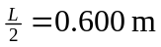, the first overtone mode has displacement nodes at 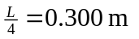  and the second overtone mode has displacement nodes at . ii) Fundamental: 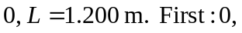 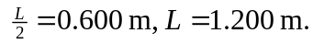
b) Refer to Fig. (16.19); distances are measured from the right end of the pipe in the figure. Pressure nodes at: Fundamental: 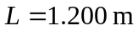. First overtone: 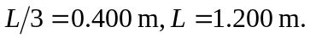Second overtone: 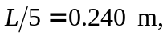 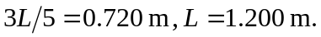 Displacement nodes at Fundamental:  First overtone: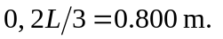Second overtone: